МИНОБРНАУКИ РОССИИ
Санкт-Петербургский государственный
электротехнический университет
«ЛЭТИ» им. В.И. Ульянова (Ленина)
Кафедра САПР

отчет
по лабораторной работе №2
по дисциплине «Алгоритмы и Структуры Данных»
Вариант 2

Студент гр. 8301 |  | Рожков В.
Преподаватель |  | Тутуева А.В.

Санкт-Петербург
2020

Постановка задачи
Реализовать алгоритм кодировки Шеннона-Фано для решения следующих задач:
- Кодировка строки (fanoCoding)
- Декодировка строки (fanoDecoding)

Оценка временной сложности
- О(NlogN)
- О(NlogN)

Описание реализованных юнит-тестов
- Попытка кодирования без ввода строки
- Кодирование и декодирование сообщения
- Проверка добавления символа в список
- Проверка подсчёта частот

Пример работы
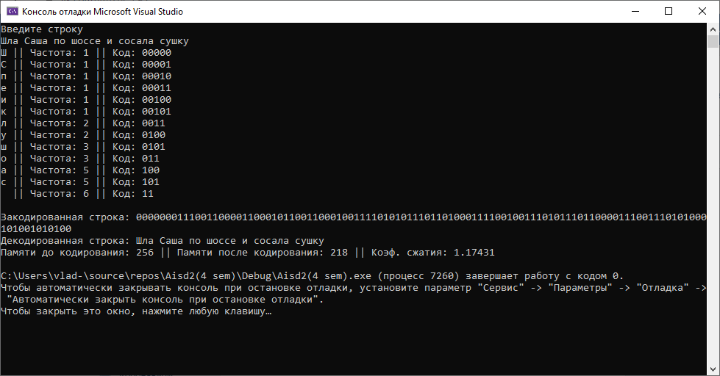
Рисунок 1
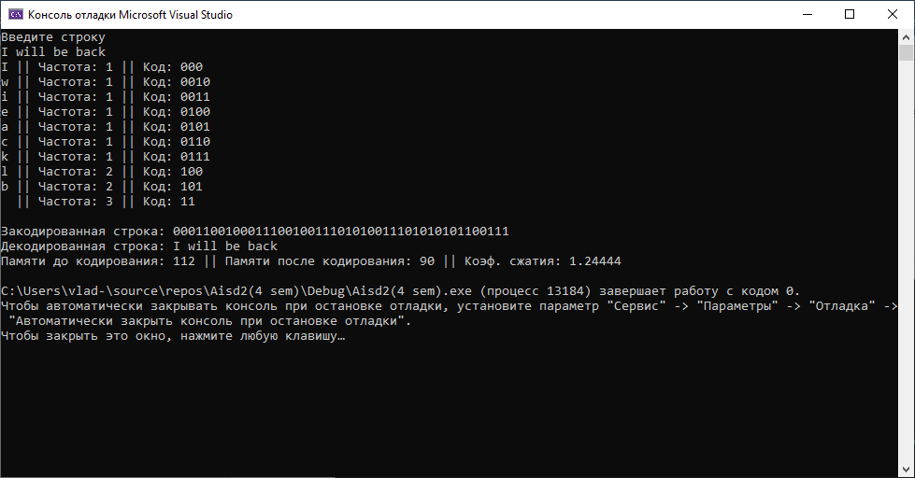
Рисунок 2
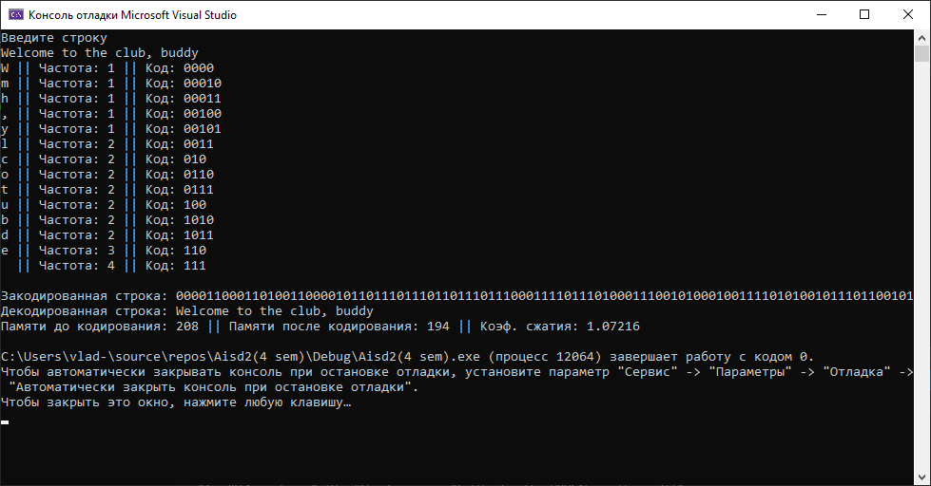
Рисунок 3

Листинг

Реализация алгоритма
#pragma once
#include <iostream>
using namespace std;

struct listElement
{
char symbol;
int frequency;
string code;
listElement* next, * prev;
};

class list
{
private:
listElement* head, * tail;

public:
list() // constructor
{
head = nullptr;
tail = nullptr;
}

~list() // destructor
{
if (head) // if list is not empty
{
listElement* buf;
while (head != tail) // until there is one element
{
buf = head;
head = head->next;
delete buf;
}
delete head;
head = nullptr;
tail = nullptr;
}
}

void check(char symbolInput) // filling the symbols list and counting frequency
{
bool found = false; // if symbol is already in list -> true
if (head)
{
listElement* cur = head; // current element
if (cur->symbol == symbolInput) // if it is first symbol
{
found = true;
cur->frequency++;
}
while ((cur != tail) && (!found)) // until no more elements left or symbol found
{
cur = cur->next;
if (cur->symbol == symbolInput) // if symbol found
{
found = true;
cur->frequency++;
}
}
if (!found) this->pushBack(symbolInput); // if there is no this symbol in the list - add it
}
else this->pushBack(symbolInput); // if list is empty - add symbol
}

void input(string text) // input of data
{
int length = text.length();
for (int i = 0; i < length; i++)
{
check(text[i]);
}
}

void sortingFrequences()
{
if (head != tail) // if more than 2 elements in list
{
bool swap; // if there were swaps on this step
listElement* buf, * cur; // temporary element and current element
do
{
swap = false;
cur = head;
while (cur != tail)
{
if (cur->frequency > cur->next->frequency) // condition of swapping
{
buf = cur->next; // the next element after current
if (cur == head) head = buf; // if current is first element, change head
if (buf == tail) tail = cur; // if next element is last, change tail
if ((buf->next)&&(cur->prev)) // if there are elements on two sides by those two elements
{
cur->next = buf->next;
buf->prev = cur->prev;
cur->prev->next = buf;
buf->next->prev = cur;
}
else if (buf->next) // if only on right side
{
cur->next = buf->next;
buf->prev = nullptr;
buf->next->prev = cur;
}
else if (cur->prev) // if only on left side
{
buf->prev = cur->prev;
cur->next = nullptr;
cur->prev->next = buf;
}
else // if not
{
buf->prev = nullptr;
cur->next = nullptr;
}
buf->next = cur;
cur->prev = buf;
cur = buf;
swap = true; // we swapped elements
}
cur = cur->next;
}
} while (swap);
}
}

void fano() // activator of recursive function
{
if (head)
{
string empty = "";
fanoRec(empty, empty, head, tail);
}
else throw logic_error("Empty list");
}

void fanoRec(string& branch, string& fullBranch, listElement* start, listElement* end) // counting codes for symbols (branch - last turn to this element(1/0), fullBranch- all turns to last element)
{
listElement* cur, * leftEnd, * rightStart; // current element, last element in left part, first element in right part
double fullSum = 0; // sum of all elements frequences
int sum = 0; // sum which we count to take a half
string curBranch = ""; // path to this element

curBranch = fullBranch + branch;
if (start == end) // if element is leaf
{
start->code = curBranch;
return;
}
cur = start;
fullSum += start->frequency;
while (cur != end) // counting sum of all elements
{
cur = cur->next;
fullSum += cur->frequency;
}
fullSum /= 2.; // counting a half of sum
cur = start;
while (fabs(fullSum - (sum + cur->frequency)) < fabs(fullSum - sum) && (cur!=end)) // until we get half or one element element
{
sum += cur->frequency;
cur = cur->next;
}
rightStart = cur;
leftEnd = cur->prev;
string zero = "0";
string one = "1";
fanoRec(zero, curBranch, start, leftEnd); // the same for left part
fanoRec(one, curBranch, rightStart, end); // the same for right part
}

string codeSearch(char symbol) // searching the code of symbol
{
if (head)
{
listElement* cur = head;
if (cur->symbol == symbol) return cur->code;
while (cur != tail)
{
cur = cur->next;
if (cur->symbol == symbol) return cur->code;
}
}
else return "";
}

int frequencySearch(char symbol) // searching the frequency of symbol
{
if (head)
{
listElement* cur = head;
if (cur->symbol == symbol) return cur->frequency;
while (cur != tail)
{
cur = cur->next;
if (cur->symbol == symbol) return cur->frequency;
}
}
else return 0;
}

string fanoCoding(string decodedText) // coding the text by codes
{
string codedText = "";
input(decodedText);
sortingFrequences();
fano();
int length = decodedText.length();
for (int i = 0; i < length; i++)
{
codedText += this->codeSearch(decodedText[i]);
}
return codedText;
}

string fanoDecoding(string codedText)
{
int length = codedText.length();
int iterator = 0, level = 0; // iterator for string, level of code (amount of digits in it)
string decodedText = "";
listElement* start, * end, * cur; // first and last elements in search area, current element
while (iterator < length)
{
start = head;
end = tail;
level = 0;
while (start != end) // until element found
{
if (codedText[iterator + level] == '0') // checking each symbol of code by level determination
{
cur = start; // if zero - we must search from start
while (cur->code[level] != '1') // searching the first element of right side
{
cur = cur->next;
}
end = cur->prev; // determining the last element of left side
level++; // change the level to next symbol
}
else // the same, but from end to start
{
cur = end;
while (cur->code[level] != '0')
{
cur = cur->prev;
}
start = cur->next;
level++;
}
}
decodedText += start->symbol;
iterator += level; // moving to next code
}
return decodedText;
}

void tableOutput() // output the table of frequences and codes
{
if (head)
{
listElement* cur = head;
cout << cur->symbol << " || Частота: " << cur->frequency << " || Код: " << cur->code << endl;
while (cur != tail)
{
cur = cur->next;
cout << cur->symbol << " || Частота: " << cur->frequency << " || Код: " << cur->code << endl;
}
cout << endl;
}
}

void pushBack(char symbolInput) // adding an element to the end of the list
{
listElement* newElement = new listElement;
if (head) // if list is not empty
{
tail->next = newElement;
newElement->next = nullptr;
newElement->prev = tail;
tail = newElement;
newElement->symbol = symbolInput;
newElement->frequency = 1;
newElement->code = "";
}
else
{
head = newElement;
tail = head;
newElement->next = nullptr;
newElement->prev = nullptr;
newElement->symbol = symbolInput;
newElement->frequency = 1;
newElement->code = "";
}
}

};

Юнит-тесты
#include "pch.h"
#include "CppUnitTest.h"
#include "c:/Users/vlad-/source/repos/Aisd2(4 sem)/Aisd2(4 sem)/List.h"

using namespace Microsoft::VisualStudio::CppUnitTestFramework;
Assert assert;

namespace UnitTest1
{
TEST_CLASS(UnitTest1)
{
public:

TEST_METHOD(fanoEmptyList)
{
bool error = false;
list* newList = new list;
try { newList->fano(); }
catch (logic_error) { error = true; }
assert.IsTrue(error);
delete newList;
}

TEST_METHOD(fanoCodingDecoding)
{
string text = "wwwcom", codedText, decodedText;
list* newList = new list;
codedText = newList->fanoCoding(text);
decodedText = newList->fanoDecoding(codedText);
assert.AreEqual(text, decodedText);
delete newList;
}

TEST_METHOD(check)
{
char letter = 'w';
list* newList = new list;
newList->check(letter);
assert.AreEqual(1, newList->frequencySearch(letter));
delete newList;
}

TEST_METHOD(input)
{
string text = "wwwcom";
list* newList = new list;
newList->input(text);
assert.AreEqual(3, newList->frequencySearch('w'));
delete newList;
}
};
}

Вывод:
Приобретены навыки кодирования и декодирования строк с помощью алгоритма Шеннона-Фано.

